**A MINOR PROJECT REPORT**

**ON**

LIBRARY MANAGEMENT SYSTEM (LMS)

SUBMITTED TO

UNIVERSITY OF SCIENCE & TECHNOLOGY, MEGHALAYA

RI-BHOI 9TH MILE, MEGHALAYA



BCA **4**TH SEMESTER

BATCH: 2017-2020

SUBMITTED BY,

YANGLEM KHOMBA MEITEI (17/BCA/38)

RAJNISH RAY (17/BCA/32)

**GUIDED BY,**

DAISY SHARMAH

ASSISTANT PROFESSOR,.

DEPT. OF COMPUTER SCIENCE & ELECTRONICS



UNIVERSITY OF SCIENCE AND TECHNOLOGY, MEGHALAYA

**CERTIFICATE**

This is to certify that the project work, entitled **“LIBRARY MANAGEMENT SYSTEM (LMS)”,** carried out by **RAJNISH RAY** **& YANGLEM KHOMBA MEITEI** bearing University Roll. No **17/BCA/32 and 17/BCA/38** respectively in partial for the award of the degree of **BCA 4th Semester** of **University of Science & Technology, Meghalaya.** They have worked under supervision of our faculty, Department Of Computer Science.

**BHAIRAB SARMA**

HOD

Department of Computer Science

University of Science & Technology, Meghalaya



UNIVERSITY OF SCIENCE & TECHNOLOGY, MEGHALAYA

**CERTIFICATE FROM GUIDE**

This is to certify that the project work, entitled **“LIBRARY MANAGEMENT SYSTEM (LMS)”,** carried out by **RAJNISH RAY & YANGLEM KHOMBA MEITEI**, 4th Semester of BCA at University of Science & Technology, and Meghalaya under my personal supervision and guidance. The report is found worthy of acceptance for the minor project of BCA 4th Semester.

**DAISY SHARMAH**

ASSISTANT PROFESSOR

Department of Computer Science

University of Science & Technology, Meghalaya

**DECLERATION**

We, Rajnish Ray (Roll No 17/BCA/32) & Yanglem Khomba Meitei (Roll No 17/BCA/38) Of BCA 4th Semester student of Department of Computer Science, University of Science & Technology, Meghalaya under the guidance of Mam, Daisy Sharmah declare that the project entitled **“LIBRARY MANAGEMENT SYSTEM”** done in partial fulfilment for the requirement for the Degree of Bachelor of Computer Application(BCA) is my original work and it has not been previously formed the basis for the award of any degree, diploma, fellowship or any other qualification.

The report submitted is genuine and no part of this report has been submitted anywhere for the award of degree from any University.

RAJNISH RAY YANGLEM KHOMBA MEITEI

(17/BCA/32) (17/BCA/38)

**ACKNOWLEDGEMENT**

We feel immense pleasure in expressing our sincere thanks and gratitude to our project guide, Mam DAISY SHARMAH , Assistant professor Computer Science Department, University of Science And Technology for his valuable guidance and constant encouragement throughout the entire project work entitled “Library Management System” without which this project would never been possible.

With Regards

YANGLEM KHOMBA MEITEI (17/BCA/38)

& RAJNISH RAY (17/BCA/32)

BCA 4th Semester

ABSTRACT

|  |  |
| --- | --- |
| 1.Title of the Project | **“LIBRARY MANAGEMENT SYSTEM”** |
| 2.Aim of the Project | The main aim of the proposed system is make a fully computerised system to maintain the record of the membership and to manage **library** daily operation efficiently. |
| 3.Organisation | **UNIVERSITY OF SCIENCE & TECHNOLOGY, MEGHALAYA** |
| 4.Purpose | 4th Semester Mini Project, required for the partial fulfilment of the award of degree of **Bachelor of Computer Application (BCA)** of **UNIVERSITY OF SCIENCE & TECHNOLOGY** |
| 5.Duration | 6 Months approx. |
| 6.Project Done By | Yanglem Khomba Meitei & Rajnish Ray |
| 7.Software Used | Operating System: Microsoft Windows 10  Front End: Microsoft Visual Studio 2008  Back End: MYSQL Server 2005 |
| 8. Hardware Used | Processor : Intel Core i3  Hard Disk: 1 TB  RAM: 4 GB DDR3 |

**TABLE OF CONTENTS**

CHAPTER NO. TITLE PAGE NO.

1. Introduction 1-4
   1. Project introduction 1
   2. Objective of the project 2
   3. Problem statement 3
   4. Propose system 4
2. Requirement Specification 5-6
   1. Requirement analysis 5
   2. Hardware specification 5
   3. Software specification 5
   4. Feasibility study 6
3. System Design 7-17
   1. Project modules 7
   2. Gantt chart 8
   3. Structure chart 9
   4. Data flow diagram symbols 10
   5. Context diagram 11

3.5.1 1st level DFD 12

* 1. ER diagram symbols 13
  2. ER diagram 14
  3. Database design 15

3.8.1Table structure 16-17

4. Testing and implementation 18-21

4.1 System Testing 18-21

5. Documentation 22-30

5.1 Output (screenshot) 22-27

5.2 Future scope 28

5.3 Conclusion 29

5.4 Bibliography 30

**LIST OF FIGURES**

|  |  |  |
| --- | --- | --- |
| **Sl no** | **Figure number** | **Figure Name** |
| 1. | 3.1 | Gantt Chart |
| 2. | 3.2 | Structure Chart |
| 3. | 3.3 | Data Flow Symbol |
| 4. | 3.4 | Context Diagram |
| 5. | 3.5 | !st Level DFD |
| 6. | 3.6 | ER Diagram Symbol |
| 7. | 3.7 | ER Diagram |
| 8. | 4.1 | Testing Process |
| 9. | 5.1 | Login Form |
| 10. | 5.2 | Home Page |
| 11. | 5.3 | Category Form |
| 12. | 5.4 | Book Entry Form |
| 13. | 5.5 | Member Registration |
| 14 | 5.6 | Book Issue Form |
| 15. | 5.7 | Book Return Form |
| 16. | 5.8 | Fine Output |
| 17. | 5.9 | Search Form |
| 18. | 5.10 | Database Viewer |
| 19. | 5.11 | Crystal Report |

**LIST OF TABLES**

|  |  |  |
| --- | --- | --- |
| **Sl. No.** | **Table number** | **Table Name** |
| 1 | 3.1 | Data Dictionary |
| 2 | 3.2 | Category Table |
| 3 | 3.3 | Books Table |
| 4 | 3.4 | Member Table |
| 5 | 3.5 | Book Transaction table |
| 6 | 3.6 | Fine Table |

**CHAPTER 1**

**1.1. INTRODUCTION:**

Almost the **LIBRARY MANAGEMEMT** the records of Members, new book entry, their details, and Member enter, Member enquiry, book enquiry, book return register etc. are maintained and manipulated. Generally, all these works are done and managed manually hence, leading to the chances of human errors that may create some problems. Thus, A secured and reliable system to handle it .

In **LIBRARY MANAGEMEMT SYSTEM**, as described above, can lead to error free, secure, reliable and fast information system.

It can assist the staff to concentrate on their other activities rather to concentrate on the record keeping. Thus it will help organization in better utilization of resources.

The organization can maintain computerized records without redundant entries. That means that one need not be distracted that is relevant much more quickly.

* 1. **OBJECTIVE:**

This project deals with the information criteria of the **LIBRARY MANAGEMEMT SYSTEM** basically the project describes how to manage for records of records of books, searching of books.

The main objectives behind the development of this project are as follows:

* To Store Books details and category details.
* To register member record.
* To retrieve Books details and category details.
* To Provide The Details Of Issue Books.
* To provide the details of book return
* To calculate and collect fine

Thus, there are a number of objectives behind developing the **“LIBRARY MANAGEMEMT SYSTEM”** and it reduces a lot of manual working of the department.

* 1. **PROBLEM STATEMENT:**

The current problem can be solved by automating the manual process followed in managing libraries with the help of our software. This would not only make the job of shorting the data very easy and fast for the librarian but it would also make the process of retrieving data (regarding books, users etc.) in the future very convenient. It would also give user the facility to search the entire books of the library.

* 1. **PROPOSED STATEMENT:**

**Proposed System** is an automated Library Management System.Through our software user .information, borrow and return books in quick time . Our propose system has the following advantages

* Manage the complete management of the entire library through the software’s easy interface.
* It removes the manual process of issuing books by easy and simplified way of issuing book saving time and effort.
* The librarian can issue and return book for a particular student through the software’s interface.
* The software automatically shows the fine levied by automatically counting days from the date of issue incase of late return of the book.
* Student can also check the availability status of a particular book.
* Generate customized report for library fine collection.

**CHAPTER 2**

**2.1. REQUIREMENT ANALYSIS**

Requirement Analysis, also called requirement engineering, is the process of determining user’s expectation for a new or modified product. These features called requirement, must be quantifiable, relevant and detailed. Requirement analysis involves frequent communication with system user to determine specific features, expectations and resolution of conflicts or ambiguity in requirement as demanded by various users. Requirement analysis is a team effort that demands a combination of hardware, software and human factors, engineering expertise as well as skills in dealing with the peoples.

**TOOLS AND TECHNOLOGY USED**

**2.2. HARDWARE SPECIFICATION:**

* Processor : Intel Core i3
* Hard Disk: 1 TB
* RAM: 4 GB DDR3

**2.3. SOFWARE SPECIFICATION:**

* Operating System: Microsoft Windows 10
* Front End: Microsoft Visual Studio 2008
* Back End: MYSQL Server 2005

**2.4. FEASIBILITY STUDY**

The objective of feasibility is not to solve the problem but to acquire a sense of its scope. The three major areas to consider while determining the feasibility of a project are:

1. Technical Feasibility Regarding the technical aspect of the project, the organization already has the latest hardware and software requirements. Therefore the project would be technically sound.
2. Economic Feasibility The institute will not have to incur additional expenses as computers are already installed. The institute doesn’t have to spend money buying syllabus book for the students instead they can provide this software.
3. Behavioural Feasibility Implementation of this project will not be a problem as the faculties of the institute are well versed with using computers.

**CHAPTER 3**

**SYSTEM DESIGN:**

**3.1. PROJECT MODULE**

In the proposed system we have divided the information into modules:-

1. Librarian: librarian is the person who manages the library. Librarian has the permission that he can access the database using login id and password there are some task which ara performed by librarian like

* Addition of new books.
* Modification of a book.
* Deletion of a book.
* Searching of a book.
* Issuing of a book.
* Returning of a book.
* Collection fine from member.
* Generating receipt.

1. Registration: in the registration module, member has to get register by supplying his/her personal information which gets stored in database which are using as back end.
2. Issuing and returning books: In this module, registered member can issue various books available in the library and have to return book on given date
3. Collect fine: in this module, fine is collected from the member, if member is failed to return the book on the given due date.

**3.2. Gantt Chart**

[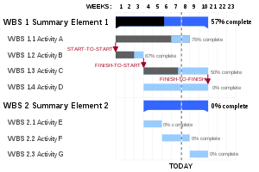](https://en.wikipedia.org/wiki/File:GanttChartAnatomy.svg)

A Gantt chart showing three kinds of schedule dependencies (in red) and percent complete indications.

A **Gantt chart** is a type of bar chart that illustrates a project schedule, named after their inventor, Henry Gantt (1861–1919), who designed such a chart around the years 1910–1915. Modern Gantt charts also show the dependency relationships between activities and current schedule status.

**Gantt Chart/Work Break Down Structure (WBDS):**

FIG: 3.1 Gantt Chart

**3.3. Structure Chart:**

**LIBRARY MANAGEMENT SYSTEM**

**FINE**

**BOOK MASTER**

**BOOK TRANSACTION**

**MEMBER**

**CATEGORY**

**RETURN**

**ISSUE**

FIG3.2: Structure Chart

**3.4. Data Flow Symbol:**

FIG 3.3: Data Flow Symbol

Left data Flow

Process

Right data Flow

Data store

Source/Sink

**3.5. Context Diagram:**

FIG 3.4: Context Diagram

Pay fine

Return books

Check category & book availability

Approve Book issue

Master entry of book details & category details

Master entry of book details & category details

Master entry of book details & category details

Master entry of book details & category details

**LIBRARIAN**

Response of checking

Request For book issue

Register

Collect fine

Get membership card

**MEMBER**

**3.5.1. 1st Level DFD:**

Store master entry of books details and category details

Checking for return

Retrieve member id

Store fine details

Fine details

Response of checking category details

Response of checking book details

Check member details

Check book details

Collect fine

Pay fine

Return book

Approve book issue

Request for book issue

Store member details

Store category details

Store book details

Checking category book availability

Get membership card

Register

MEMBER

LIBRARIAN

Category

details

Book details

Member

details

Response of checking

Update issue book details

Storing book issue details

Book issue & return

Storing return details

FIG 3.5: 1st Level DFD

Store fine details

Checking issue and return details

**3.6. ER Diagram Symbols:**

Entity

FIG 3.6: ER Diagram Symbol

Foreign Key

Cardinality ratio

Primary Key

**1:1**

**1:M**

**M:1**

**M:N**

Attribute

Relationship

**3.7. ER Diagram:**

FIG 3.7: ER Diagram

**PAY**

**BOOKS**

**ISSUE / RETURN BOOK**

**ISSUE**

**BOOK**

**FROM**

**MEMBER**

**FINE**

**CATEGORY**

**N**

**M**

**1**

**1**

**M**

**1**

**3.8. Database Design:**

**DATA DICTIONARY**

|  |  |  |  |  |
| --- | --- | --- | --- | --- |
| Sl_no | Field_Name | Description | Source Table | Constraint |
| 1 | Address | Member Address | Member |  |
| 2 | Author | Book Author | Books |  |
| 3 | Cate_id | Category ID | Category | Primary key |
| 4 | Cate_name | Category Name | Category |  |
| 5 | Copies | Copies | Books |  |
| 6 | Delay | Delay Days | Fine |  |
| 7 | Dept | Department | Member |  |
| 8 | Due_date | Due date | Book_transaction |  |
| 9 | Edition | Edition | Books |  |
| 10 | Email | Email | Member |  |
| 11 | Fine_amount | Fine amount | Fine |  |
| 12 | Gender | Gender | Member |  |
| 13 | ISBN | ISBN | Books | Primary key |
| 14 | Issue_date | Issue date | Book_transaction |  |
| 15 | Mem_id | Member ID | Member | Primary key |
| 16 | Name | Member Name | Member |  |
| 17 | Price | Book Price | Books |  |
| 18 | Publisher | Book Publisher | Books |  |
| 19 | Reciept_no | Receipt no | Fine | Primary key |
| 20 | Register_date | Register date | Member |  |
| 21 | Return_date | Return date | Book_transaction |  |
| 22 | Status | Book Status | Books |  |
| 23 | Status | Pay Status | **B**ook_transaction |  |
| 24 | Title | Book Title | Books |  |
| 25 | Valid | Member Validity | Member |  |

TABLE NO. 3.1: Data Dictionary

**3.8.1. Tables Structure:**

(i). **Category**

|  |  |  |  |  |
| --- | --- | --- | --- | --- |
| **Field** | **Type** | | **Size** | **Key** |
| Cate_id  Cate_name | | int  varchar | 10  30 | PRIMARY KEY |

TABLE NO. 3.2: Category Table

(ii). **Books**

|  |  |  |  |
| --- | --- | --- | --- |
| **Field** | **Type** | **Size** | **Key** |
| ISBN  Title  Price  Copies  Publisher  Cate_id  Edition  Author  Status | int  varchar  decimal  varchar  varchar  int  varchar  varchar  varchar | 10  20  8,2  8  20  10  20  20  16 | PRIMARY KEY  FOREIGN_KEY |

TABLE NO. 3.3: Books Table

(iii). **Member**

|  |  |  |  |
| --- | --- | --- | --- |
| **Field** | **Type** | **Size** | **Key** |
| Member_id  Name  Address  Gender  Dept  Email  Phone  Register_date  valid | int  varchar  varchar  varchar  varchar  varchar  bigint  date  date | 10  20  40  10  15  30  20  30  30 | PRIMARY KEY |

TABLE NO. 3.4: Member Table

(iv). **Book_transaction**

|  |  |  |  |
| --- | --- | --- | --- |
| **Field** | **Type** | **Size** | **Key** |
| ISBN  Member_id  Issue_date  Return_date  Due_date | int  int  date  date  date | 10  10  30  30  30 | FOREIGN KEY  FOREIGN KEY |

TABLE NO. 3.5: Book_transaction Table

(v).**Fine**

|  |  |  |  |
| --- | --- | --- | --- |
| **Field** | **Type** | **Size** | **Key** |
| Reciept_no  ISBN  member_id  name  Issue_date  Due_date  Return_date  Delay  Fine_amount  Status | int  int  int  varchar  date  date  date  int  decimal  varchar | 10  10  10  30  30  30  30  8  8,2  10 | PRIMARY KEY  FOREIGN KEY  FOREIGN KEY |

TABLE NO. 3.6: Fine Table

**CHAPTER 4**

**TESTING AND IMPLEMENTATION:**

**4.1. SYSTEM TESTING**

TESTING and TYPES:

Testing makes a logical assumption that identify (1) whether all the parts of the system are correct and (2) the goal of the candidate system is successfully achieved or not. The first test is to see whether it provides correct output result or not as per user requirements. Testing can be said to be the process of “finding the error we don’t know is there”.

A system should always be tested thoroughly before implementing it, as regards its individual programs, the system as a whole, user’s acceptance etc. Effective testing early in the process translates directly into a long term testing involves:

1. Module Testing
2. Sub-system Testing
3. System Testing and
4. Acceptance Testing

With the help of the following diagram we can illustrate the testing process:

FIG 4.1: Testing Process

Acceptance Testing

System Testing

Sub-System Testing

Unit

The testing of the system in hand, the “STUDENT MANAGEMENT SYSTEM” was carried out as described below:

**1. Module Testing or Unit Testing:**

It checks for errors in individual modules isolating them from the rest of the software product and the errors are corrected for each individual unit. This type if testing may be conducted in parallel for several modules at a time.

Here the program unit or functions are tested with:

1. Legal data values i.e. , simple realistic value,
2. Null values,
3. Illegal data values and
4. Program’s behaviour is tested under stress of extreme conditions (either the quality of data we provide or its operating environment).

**2. Sub-System Testing:**

Sub-system testing involves testing a collection of modules that have been integrated into sub-system. The sub-system may be independently designed and implemented. The errors that are not discovered into module or unit testing but discovered into sub-system testing may be:-

1. Errors in the interface between two months,
2. Errors or misunderstanding in interpreting the module specifications,
3. Errors due to side-effects of a module (i.e. some module may change the global data variables).

**3. System Testing:**

Here interface between two sub-systems are tested because errors exists in the interface between two sub-systems may not be visible until they are combined tested as a complete unit.

After combining the individual sub-system, the overall program is tested for determining whether the correct individual sub-system fit together properly into a correct whole, the system.

System testing should be concerned with ‘checking’ so that the system meets the organisation’s objectives and its requirements.

System testing is divided into two types:-

* White-Box Testing or Structural Testing
* Black-Box Testing or Functional Testing

**i)White-Box Testing:**

White-Box testing is concerned with the implementation of the programs. In this type of testing different programming structures and data structures used in the program are tested for proper operations. This test concentrates on the examination of the coding methods. The system software engineers and programmers formulate test-cases and select test data. The system designers create test cases which have the possibility of locating errors.

**ii)Black-Box Testing:**

Black-Box Testing is concerned with the proper examination of the proper examination of the programs specifications. In this testing, each function as well as sub-programs used in the main programs is first identified.

Hereafter, test cases are derived to test each function or sub-program separately. Test cases are decided solely on the basis of the requirements or specifications of the programs and not on the basis of the coding of the modules or the type of the data structures used.

Black-Box testing is complementary to White-Box techniques. It uncovers a different class of errors which are not discovered by White-Box methods.

**4. Acceptance Testing:**

Acceptance Testing is the system testing performed by the customer to determine whether or not to accept the delivered of the system. This last phase of testing determines whether or not the program is considered as finished product and can be released for general use. It differs from module testing or system testing in two following ways:

1. It is typically done by the end-user nut not the programmer,
2. It is carried out without the knowledge of the internal structure and organisation of the program.

In acceptance testing we check for the program’s user-friendliness, robustness and online (help) assistance. Acceptance testing often demonstrates errors in the system requirement’s definition. It is the process of setting the system with real data the information, which the system is intended to manipulate.

A system’s acceptance testing is a final system test performed by end-user using real data over an extended time period. It is an extensive test that addresses three levels of acceptance testing:

1. Verification by Alpha Testing
2. Validation or Beta Testing and

**Alpha Testing:**

Alpha testing refers to the testing carried out by the test within the organisation. It is also known as verification testing.

The verification testing runs the system simulated environment using simulated data. The simulated test is primarily looking for errors and omissions regarding end-user and design specification that were specified in the earlier phases but not fulfilling during construction.

**Beta Testing:**

Beta testing is the system performed by group friendly customers. It is also known as Validation testing. Validation testing runs system in a live environment using real data. During this validation, we are testing a number of items such as:

1. System performance
2. Peak workload processing performance
3. Human engineering test
4. Methods and procedures test
5. Backup and recovery testing

**Testing Reports:**

* Only Alphabets are accepted in Name.
* Only Numeric is accepted in Account and Basic
* When entering data if any fields remains blank then it will show error.

**CHAPTER 5**

**DOCUMENTATION:**

**5.1.** **OUTPUT (Screen Shot)**

1. LOGIN OUTPUT

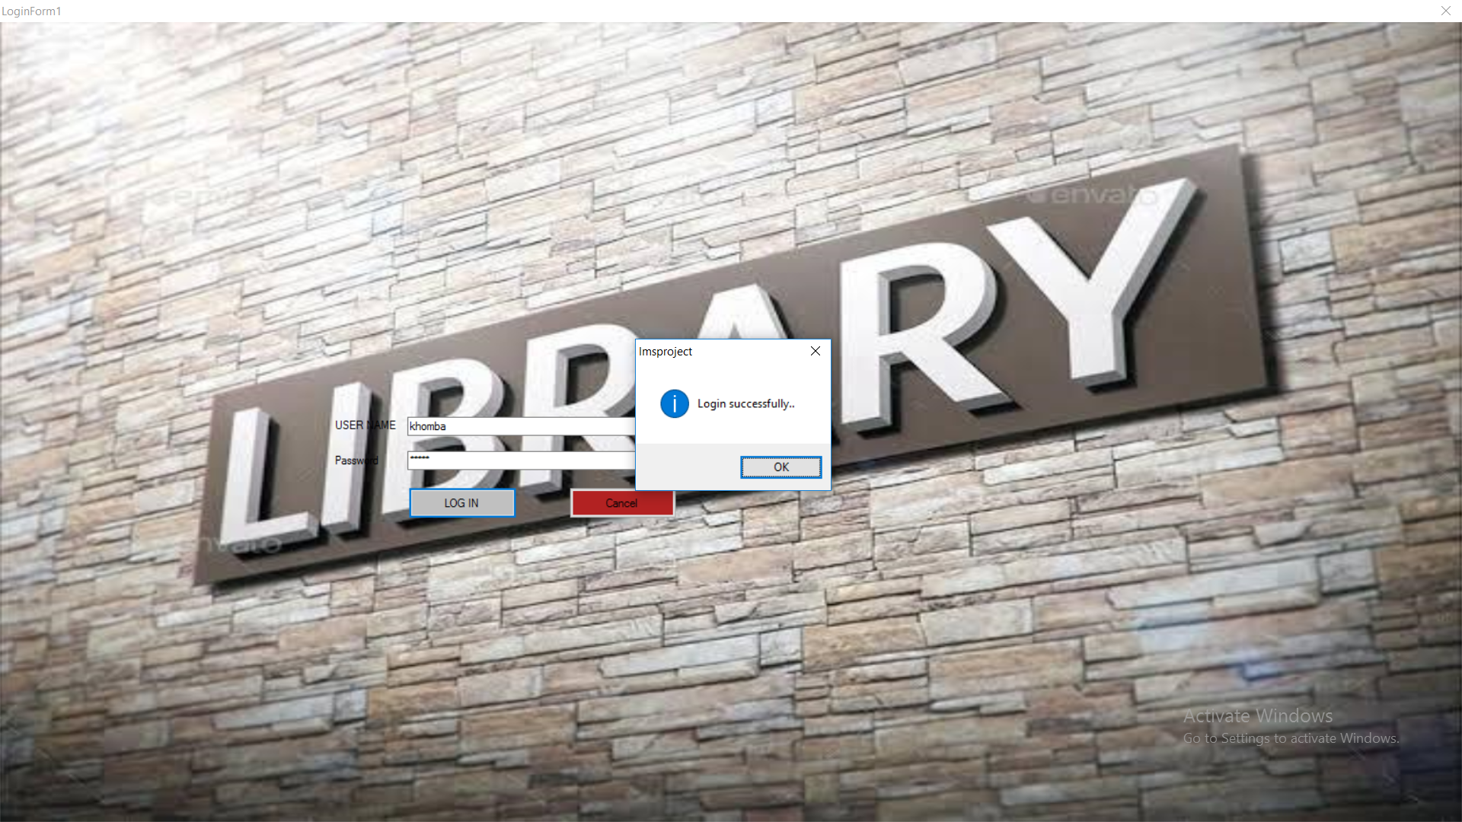

FIG 5.1: Login Form

1. MDIFORM OUTPUT

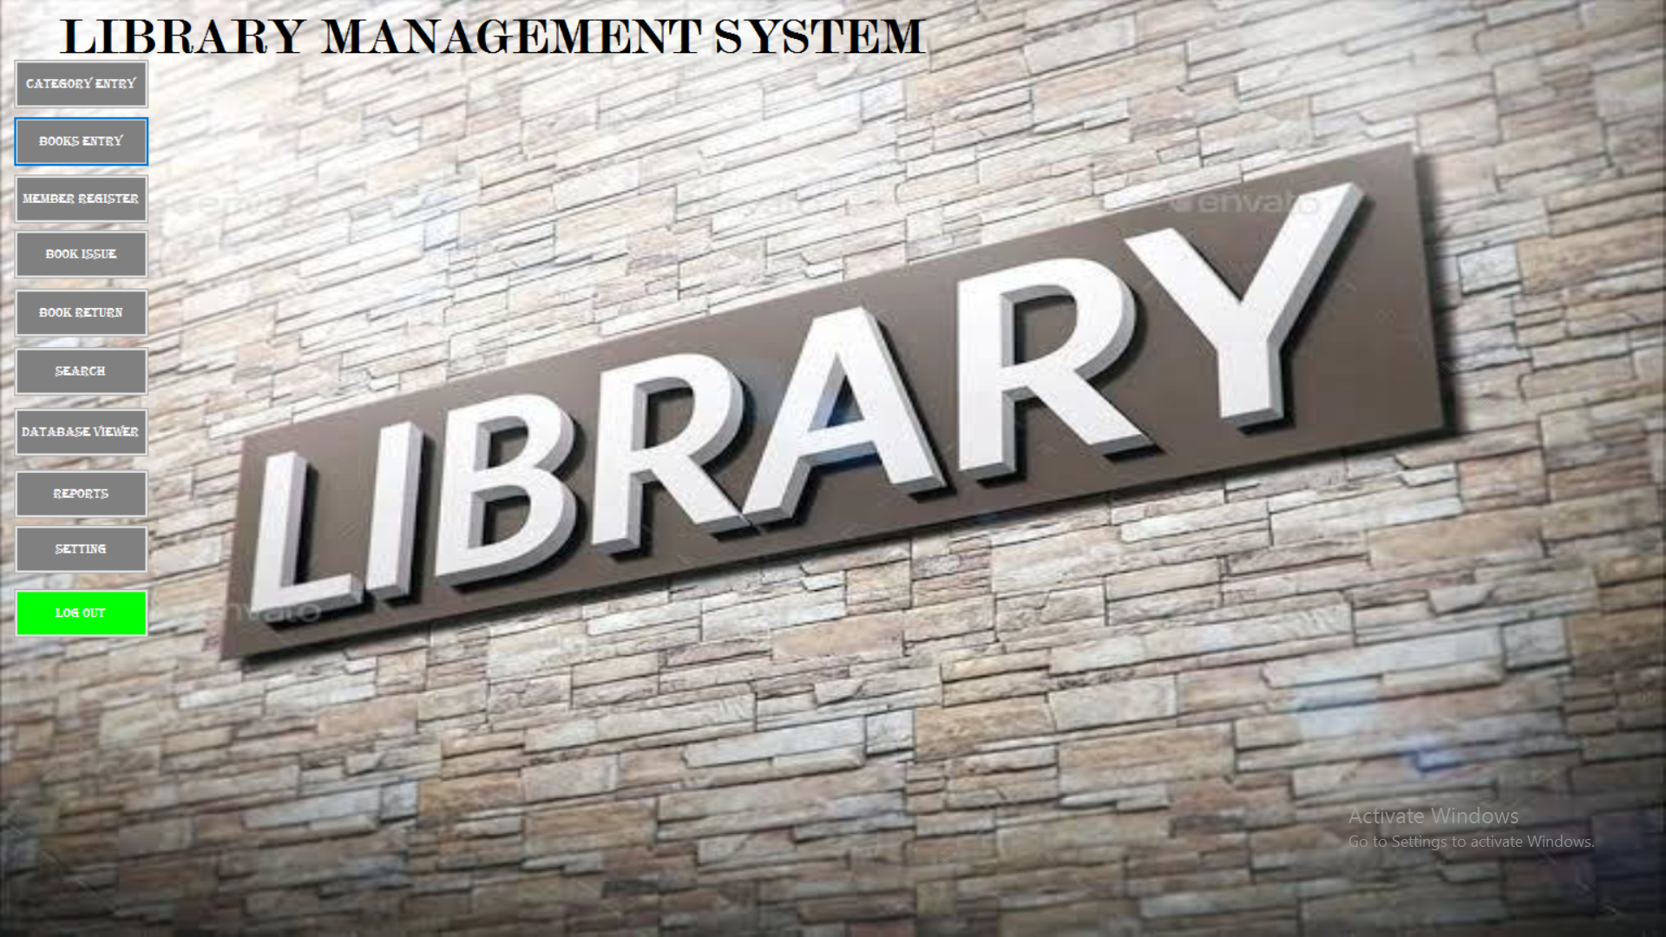

FIG 5.2: Home Page

1. ADD CATEGORY OUTPUT

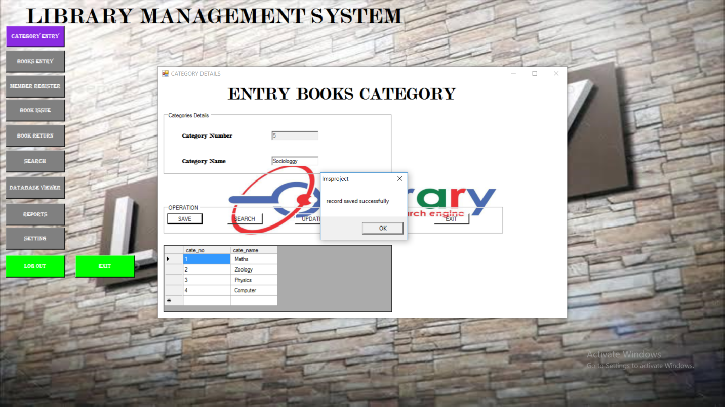

FIG 5.3: Category forms

1. BOOK MASTER OUTPUT

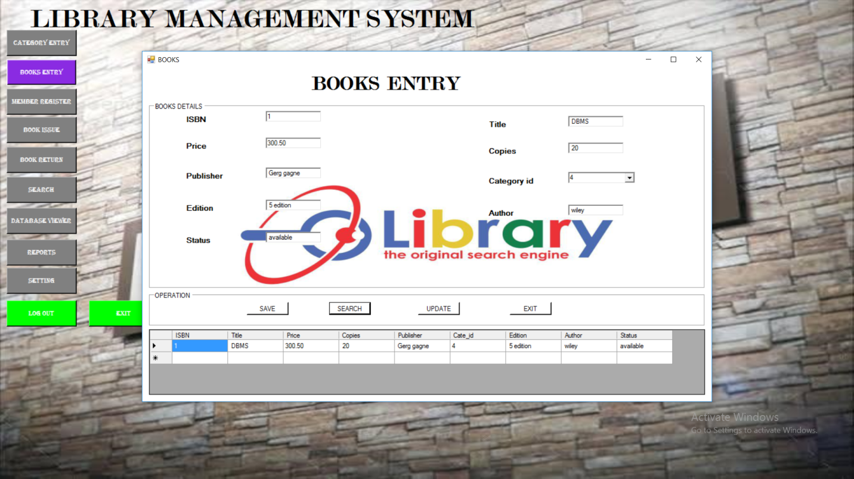

FIG 5.4: Book Entry form

1. MEMBER OUTPUT

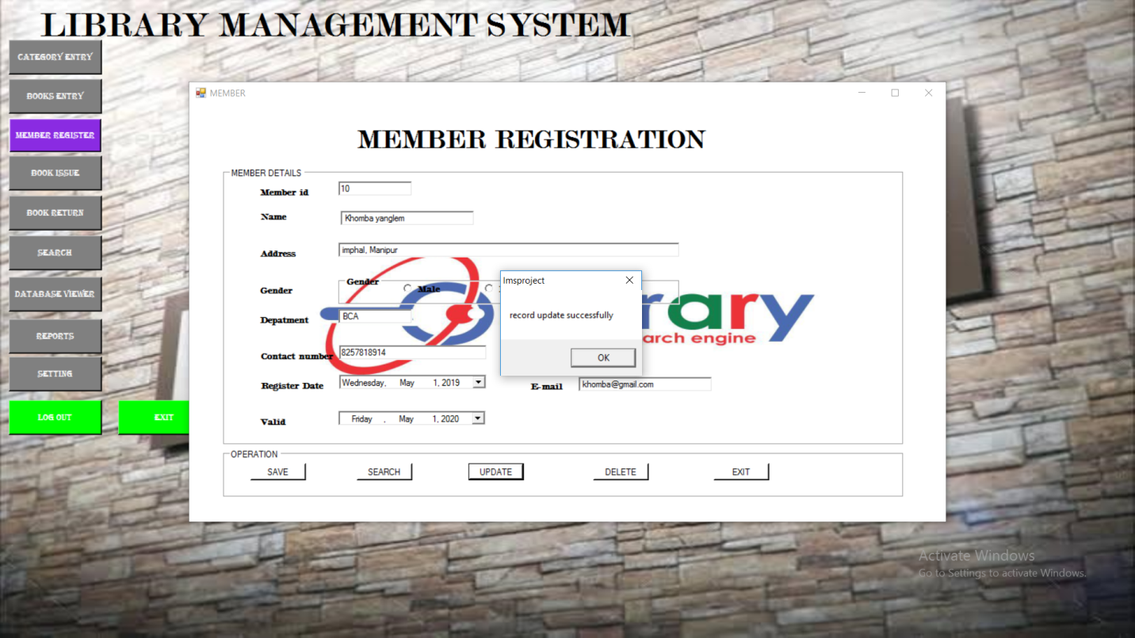FIG 5.5: Member Registration form

1. ISSUE BOOK OUTPUT

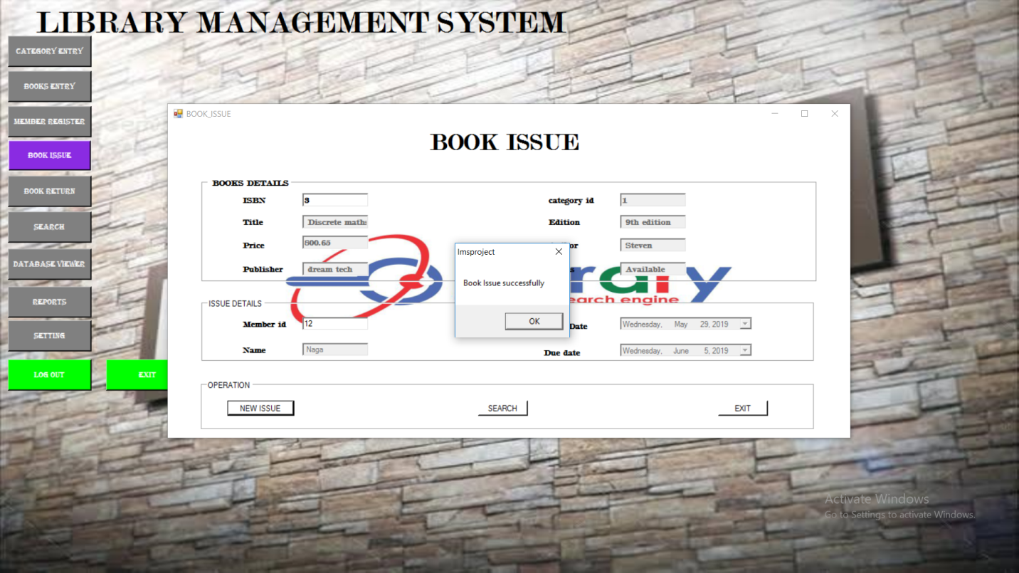

FIG 5.6: Book Issue form

1. RETURN BOOK OUTPUT

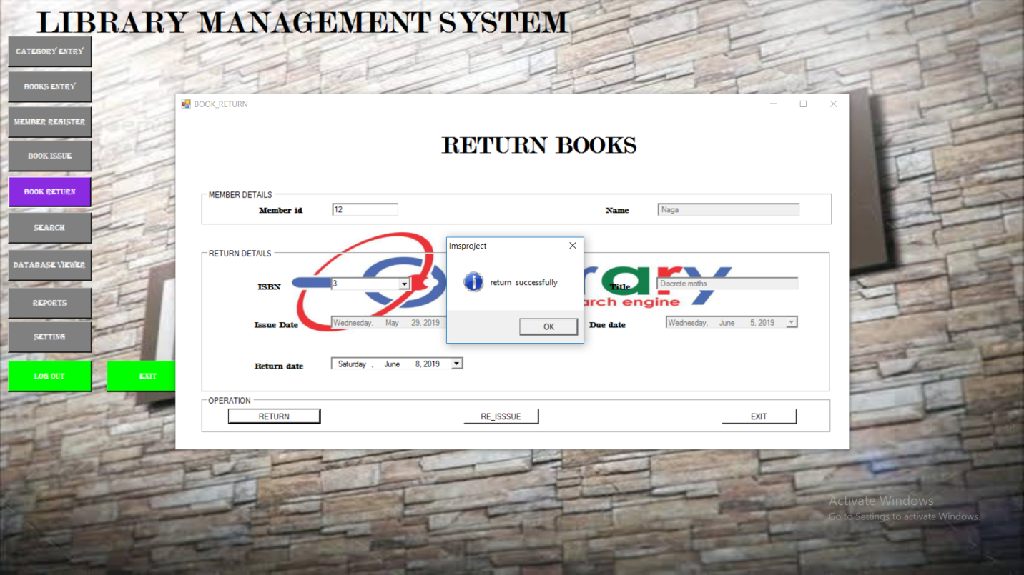

FIG 5.7: Book Return form

1. FINE OUTPUT

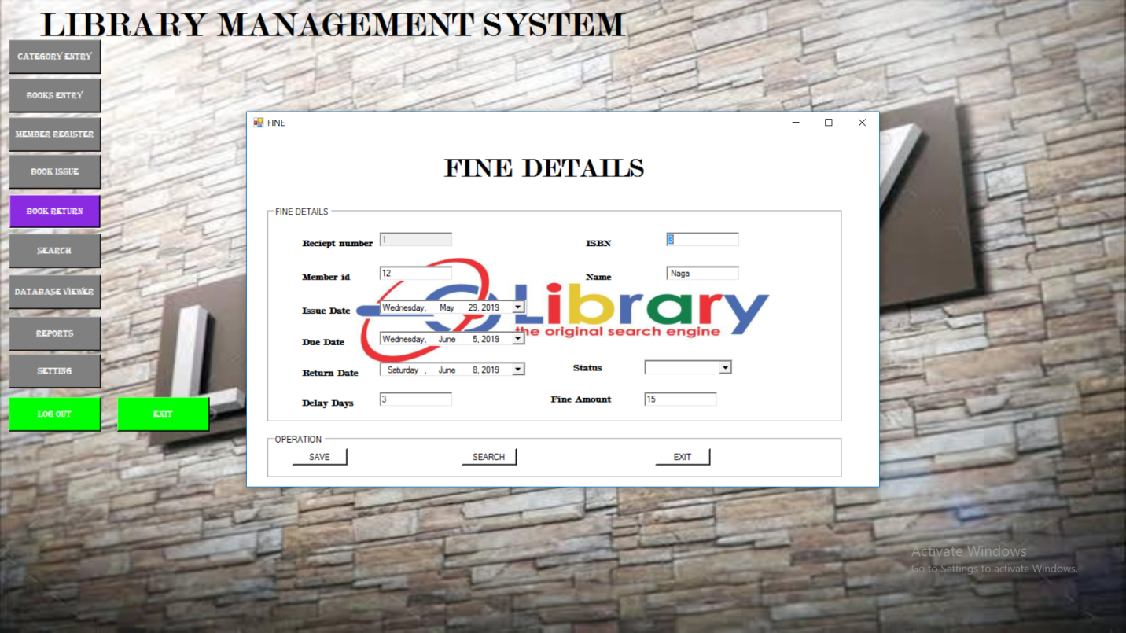

FIG 5.8: Fine Output

1. SEARCH DETAILS OUTPUT

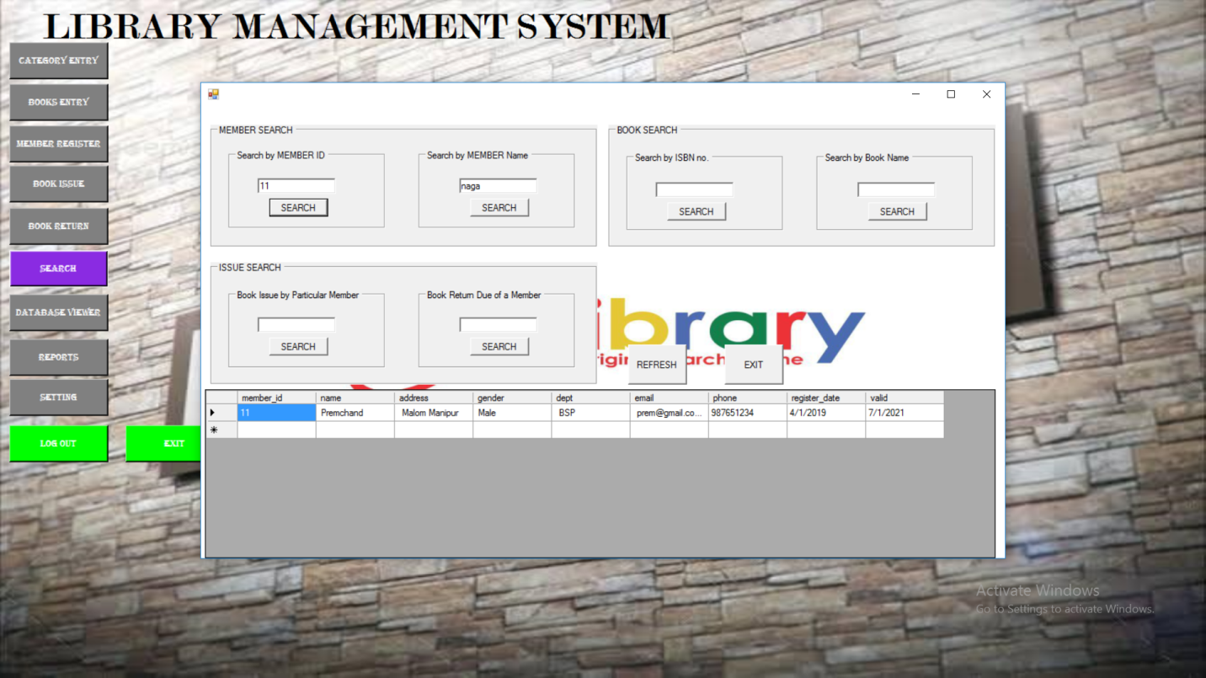

FIG 5.9: Search form

1. DATABASE VIEWER OUTPUT

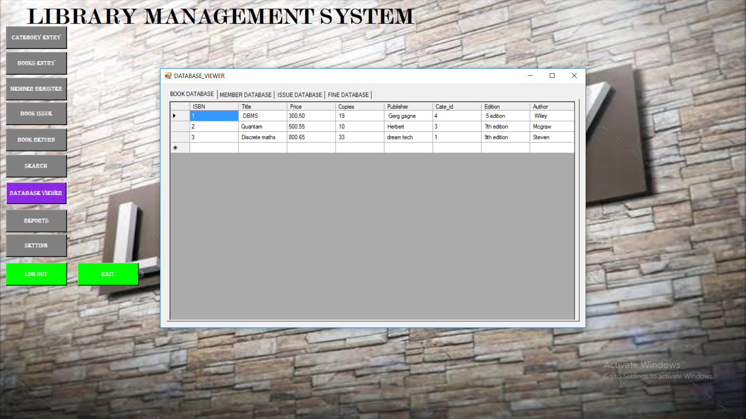

FIG 5.10: Database Viewer

Xi CRYSTAL REPORT

1. FINE RECIEPT

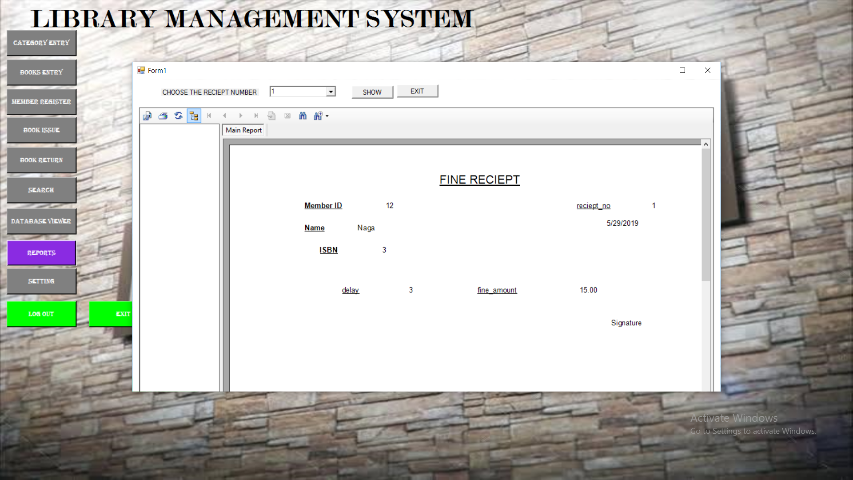

FIG 5.11: Crystal report

**5.2. FUTURE SCOPE**

There is a future scope of this facility that many more futures such as online request were member can search books, re-issue books, staff can generate reports and do book transactions .Facility for member login and can see status for book issue as well request for book and if some suggestion. Facilities for teachers login from various institutes where teachers can add lectures notes and also give some suggestion to library

**5.3. CONCLUSION**

After we have completed the project we are sure the problems in the existing system would overcome. The “**LIBRARY MANAGEMENT SYSTEM**” process made computerized to reduce human errors and to increase the efficiency. The main focus of this project is to lessen human efforts. The maintenance of the records is made efficient, as all the records are stored in the ACCESS database, through which data can be retrieved easily. The navigation control is provided in all the forms to navigate through the large amount of records. If the numbers of records are very large then user has to just type in the search string and user gets the results immediately. The editing is also made simpler. The user has to just type in the required field and press the update button to update the desired field.

The Books and Students are given a particular unique id no. So that they can be accessed correctly and without errors. Our main aim of the project is to get the correct information about a particular student and books available in the library.

The problems, which existed in the earlier system, have been removed to a large extent. And it is expected that this project will go a long way in satisfying user’s requirements. The computerization of the Library Management will not only improves the efficiency but will also reduce human stress thereby indirectly improving human recourses.

**5.4. BIBLIOGRAPHY**

.Visual Basic.NET Programming, Black Book - Steven Holzner

Software Engineering - Rajiv Mall

<http://www.scribd.com>

<http://www.mysql.com>

<http://www.mysql.org>

<http://mytutorial.com>